Mumbai naka Police station — Ganpati Mandals 2025
Total Mandals Covered: 21
Sr. No. | Mandal Name | Nodal Officer (Assigned) | Contact No. | QR Code (Location) | Google Maps Link
1 | Bhim Eko Hinur Mitra Mandal | nan | nan | 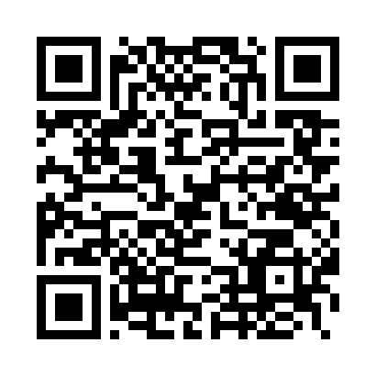 | Open Map
2 | Dharma Ekta Sai Group | nan | nan | 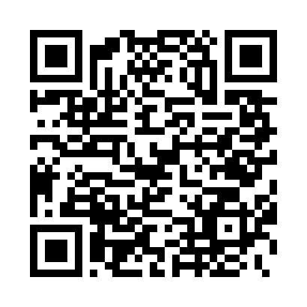 | Open Map
3 | General Arunkumar Vaidya Nagar Art, Sports and Cultural Friends Mandal | nan | nan | 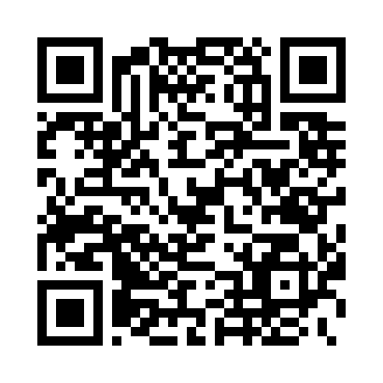 | Open Map
4 | Happy Home Colony Cultural Arts and Sports Friends Mandal | nan | nan | 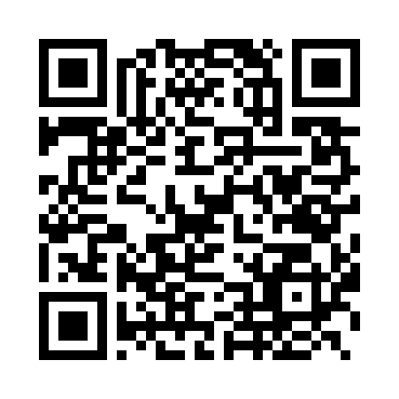 | Open Map
5 | Janata Raja Mitra Mandal | nan | nan | 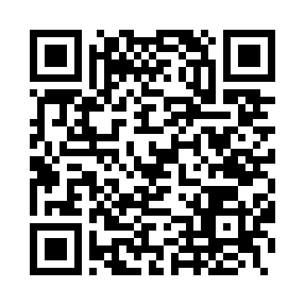 | Open Map
6 | Kalpataru Nagar Yuva Mitra Mandal | nan | nan | 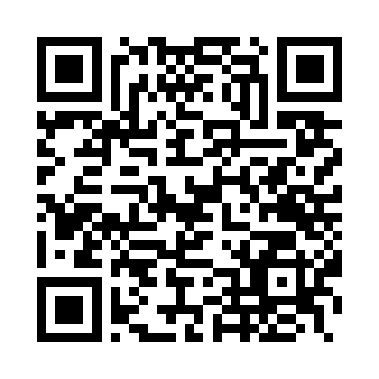 | Open Map
7 | Morya Friends Circle | nan | nan | 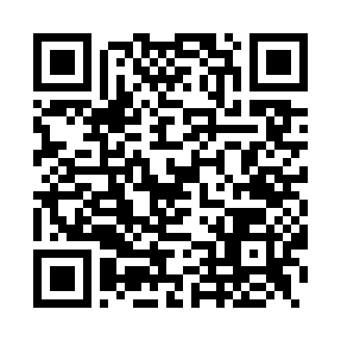 | Open Map
8 | Muchita Nagar Mitra Mandal | nan | nan | 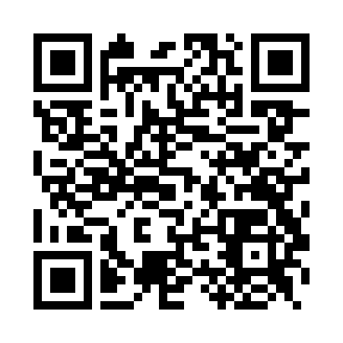 | Open Map
9 | Om Sai Mitra Mandal | nan | nan | 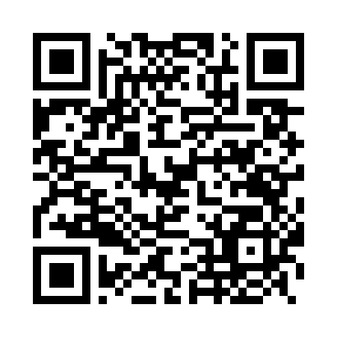 | Open Map
10 | Renuka Yuva Cultural Arts and Sports Mandal | nan | nan | 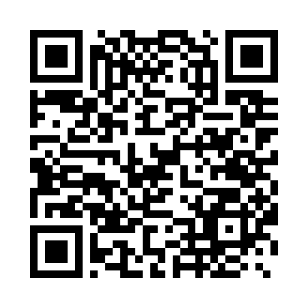 | Open Map
11 | Sahyadri Mitra Mandal | nan | nan | 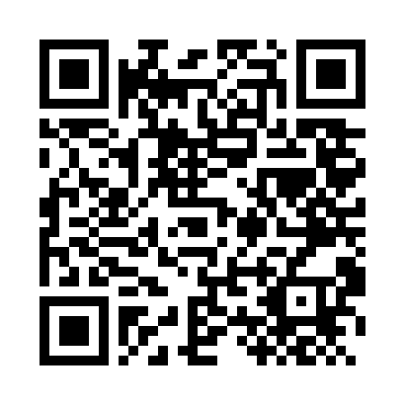 | Open Map
12 | Sai Shraddha Youth Foundation | nan | nan | 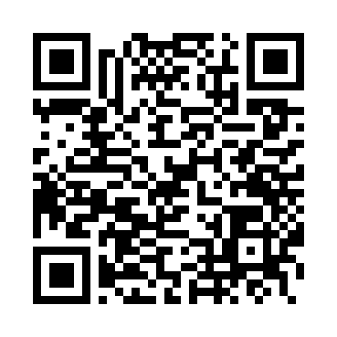 | Open Map
13 | Shitaladevi Mitra Mandal | nan | nan | 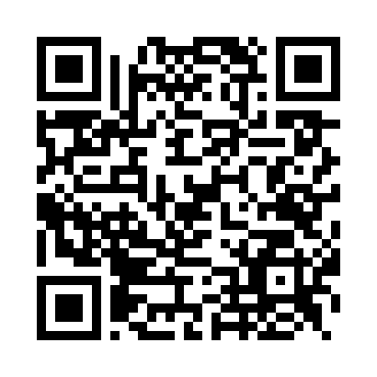 | Open Map
14 | Shivgarjana Mitra Mandal | nan | nan | 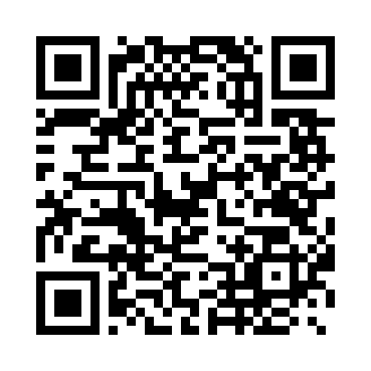 | Open Map
15 | Sri Sri Ravi Shankar Marg Friends Circle | nan | nan | 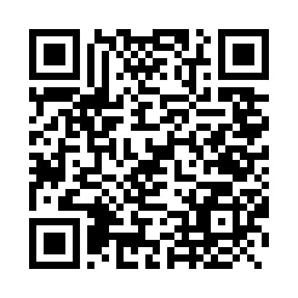 | Open Map
16 | United Friends Circle | nan | nan | 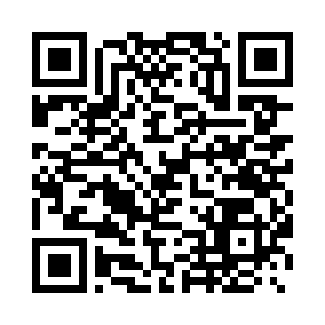 | Open Map
17 | United Friends Circle | nan | nan |  | Open Map
18 | Vighnaharta Mitra Mandal | nan | nan | 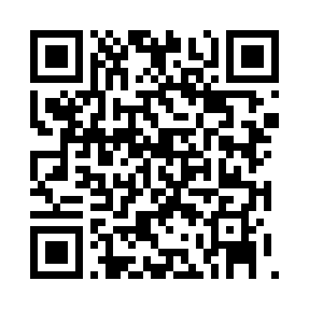 | Open Map
19 | Vighnaraj Mitra Mandal | nan | nan | 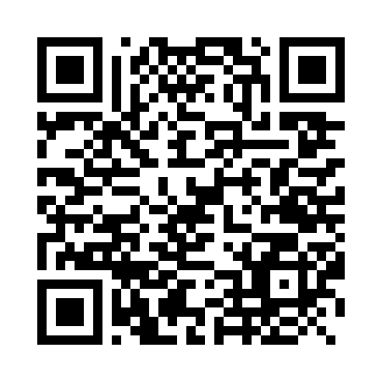 | Open Map
20 | Wadala Naka Friends Circle | nan | nan | 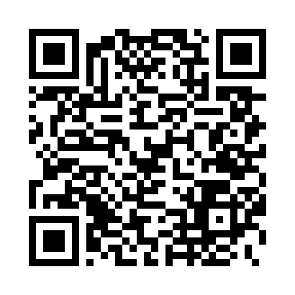 | Open Map
21 | Yuva Mitra Mandal (Mulyavan) | nan | nan | 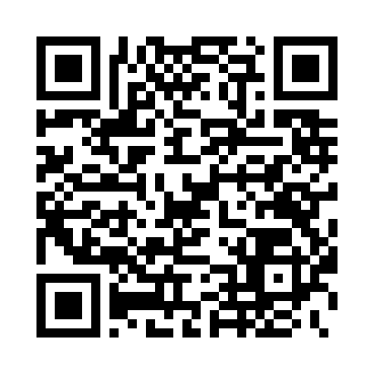 | Open Map
Auto-compiled | Source: KML + bandobast sheets | Date: 2025-09-03

